Curriculum Vitae
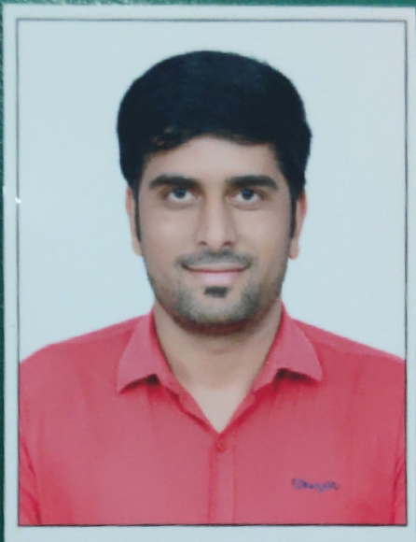
Manish Kumar Jain
Plot No. 227-A, Parshawnath Colony, Maruti Nagar,
Near Airport, Jaipur (Rajasthan) Pin - 302029
Mobile: +91 9352632052
Email: jain.manish2790@gmail.com

Career Objective
To get a challenging job in a reputed company where I can contribute efficiently by using my Technical & Professional skills and abilities and full filling the responsibilities given to me, also prove myself as a valuable asset to the organization.

Work Experience :- 9 Year
- Worked as Sr. Web Designer in WITH U Technology Pvt. Ltd. from October 2020 to September 2024.
- Worked as Sr. Web Designer in Aigutech Technologies Pvt. Ltd. from March 2018 to September 2020.
- Worked as Web Designer in Dreams Info soft Technology Pvt. Ltd. from March 2016 to March 2018.
- Worked as Web Developer & Designer in Blue Doodle .in from March 2015 to March 2016.
- Worked as Web Developer & Designer in Nextgen Infosolution Pvt. Ltd. from Sep. 2014 to Feb. 2015.

- Roles & Responsibilities:-
- Responsive Websites, W3C Valid Website, Bootstrap Websites, .NET Website design, HTML Pages , J-Query, CSS of various Projects.
- Executing the Design, Development, Troubleshooting and Debugging of the Website.
- Understanding user requirements, mapping them to system requirements and incorporating changes in the Websites as required.

Technical Key Skills
- Operating System | Windows.
- Language | .NET, ASP .NET,
- Web Technology | UI Designing, ASP.NET, HTML, HTML 5, Java Script, CSS, CSS3, Responsive Website, Ajax, Bootstrap, W3C Valid Website, Adobe Dreamweaver, Sublime Text, Wordpress, Figma to HTML, PSD to HTML, WIX, Saas.
- Databases | MS Access, MS SQL, Oracle.
- Web Server | Windows Server, Linux Server.
- Social Media | Facebook, Instagram, Youtube, LinkedIn, Meta Ad.
- Graphics | Canva, Adobe Photoshop.

Education
Qualification | College/University | Aggregate | Year of Passing
MCA | Sikkim Manipal University | 64% | 2012
BCA | Tilak Maharashtra Vidhyapeeth, Pune | 77.23% | 2010
HSC | Rajasthan Board | 55.08% | 2007
SSC | Rajasthan Board | 48% | 2005

Training
- Six month internship from Nextgen Infosolution PVT. LTD., Ajmer in ASP.NET.

Online Project
- Rawat College : https://www.rawatcollege.in/
- OBG Outsourcing : https://obgoutsourcing.com/
- Learning Temple : https://www.learningtemple.co.in/
- WITH U IT Services : https://www.withuitservices.com/
- News Thikana : https://www.newsthikana.com/
- Jaipur Music Festival : https://www.jaipurmusicfestival.com/
- IFT Hair Science : https://www.ifthairscience.com/
- Minova Paints & Coatings : https://www.minovapaints.com/
- H&H Global Education : https://www.hhglobaleduindia.com/
- Sanskar Marine Academy : https://www.sanskarmarineacademy.com/
- 360 Accounting Pro : https://www.360accountingpro.com/
- Akkyclicks Photography : https://www.akkyclicksphotography.com/
- The Vintage Saga : https://www.thevintagesaga.com/
- Aditya News Network : https://adityanewsnetwork.com/
- Lady Loyall Clinic : https://www.ladyloyallclinic.com/
- Baba Quartz : http://babaquartz.com/
- HI Elite Quartz : http://www.hielitequartz.com/
- Rita Rugs: http://ritarugs.com/

Strengths
- Good Communication Skills.
- Punctual and Regular.
- Hard Working.
- Flexible and Quick Learner.
Personal Information :-

Father Name : Mr. Rajendra Kumar Jain
Father Occupation : Service (Shri Ram Process)
DOB : 1st June- 1990
Marital Status : Married
Language Known : Hindi, English, Marathi.

Declaration :

I hereby declare that the above-mentioned information is correct up to my knowledge and I bear the responsibility for the correctness of the above-mentioned particular.

(Manish Kumar Jain)

