CURRICULUM VITAE
SAURABH MAHAWAR. 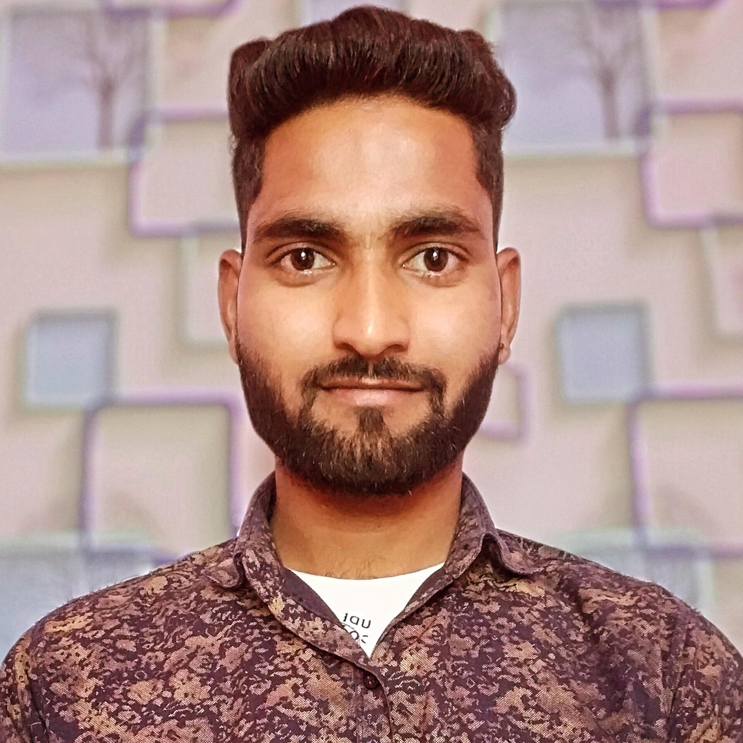 S/O Sh. -Jitendra Mahawar
V. P. - Ramgarh, Th.-Mahuwa,
District-Dausa, (Rajasthan). 321608
Mob. No. 7690894250
Email id : saurabhramgarh0@gmail.com
Career Objective :-
To seek a professional career in an organization that provides a challenging and growth oriented environment where I could use best of my knowledge and potential in conduction with the organization goals and objectives.
Educational Qualification :-
> 10th Passed from RBSE Bord, Ajmer (2013).
> 12th Passed from RBSE Bord, Ajmer (2015).
> Graduation(B.A.) From Rajasthan University, Jaipur (2019).
> iTi (Electrician) from City Pvt. industrial institute Sikar (2023).
Other Qualification :-
> Computer Basic Knowledge. (RS-CIT) (2016).
> Domestic data entry operator. Course (2021).
Work Experience :--> 7 months Experience in wedding Event Staff Management. jaipur (job role Supervisor) sep. 2023 to mar. 2024.
> 3 months experience in Leeroy Product Pvt. Ltd. Jaipur ( job role Sales Executive ) Apr. 2024 to Jun. 2024.
Strength:-
> Good Communication Skill, Good Decision Power & Positive Attitude
> Smart & Hard Worker> Honest, Time Punctual, and Quick Learner
Hobbies:-> Listening to Music, Dancing, Playing Games.
Personal Details:-
Father's Name : Mr. Jitendra Mahawar
Gender : Male
Date of Birth : 1 aug. 1997
Marital Status : Unmarried
Nationality : Indian
Languages Known : Hindi & English

Declaration:- I hereby declare that all the information furnished above is true to the best of my knowledge.

DATE:-
Place-: (SAURABH MAHAWAR)

